ICRAMCS 2026  THE EIGHTH EDITION OF THE INTERNATIONAL CONFERENCE ON RESEARCH IN APPLIED MATHEMATICS AND COMPUTER SCIENCE  April 23-24-25, 2026 | Marrakech, Morocco | 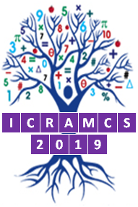  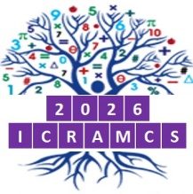

Title

Communication Info |  | Abstract
Authors:  First name LAST NAME¹  First name LAST NAME ²  First name LAST NAME ^{3,4}  ¹ Institution, City, Country  ² Institution, City, Country  ³ Institution, City, Country  ⁴ Institution, City, Country  Keywords:  (1) Keyword1  (2) Keyword2  (3) Keyword3 |  | The abstract body should be short (1 page A4), clear, concise, and written in English or in French with correct spelling and good sentence structure (Please write an Abstract of approximately 15 lines with 5 references cited within the abstract.).  Mathematical symbols and equations must be typed in, and metric symbols should be used [1].  Abstracts should be carefully thoroughly checked, in particular with regard to the list of authors, before submission in order to avoid last minute changes [2].  ICRAMCS 2025 reserves the right to reject abstracts that are not written in English or in French, do not meet basic standards of scientific quality [3].  The official languages of the ICRAMCS 2025 are French and English. Simultaneous interpretation is not provided [4]. It is therefore expected that authors are able to present their research in the English language or in the French language [5].
© ICRAMCS 2026 Proceedings ISSN: 2605-7700
References
[1] Authors, Title Journal, Volume, Year, Pages.
[2] Authors, Title Journal, Volume, Year, Pages.
[3] Authors, Title Journal, Volume, Year, Pages.
[4] Authors, Title Journal, Volume, Year, Pages.
[5] Authors, Title Journal, Volume, Year, Pages.

